**Comans – Client & Maintenance Modules**

**Phase 1**

* Client Registration
* Preventative & Corrective Maintenance
* Site Problem Reporting

**Client Registration**

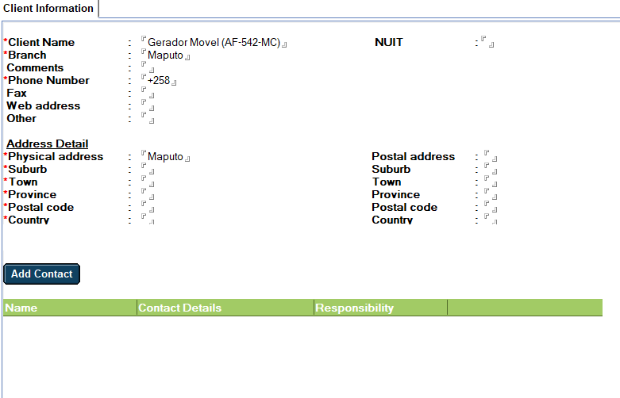

All **Client Name** must be in Proper Case do if the user saves, the system must automatically change to Proper Case

**Client Code** Must be a unique number generated in format CCN/MMYR/0001

**Client Name**

**NUIT**

**Branch**

**Phone Number**

**Address** : Street , Town, Suburb, Province, Code, Country *(If company has postal address option to add must exist)*

**Contact**

Should be able to have more then one contact per client

**Name**

**Surname**

**Job title**

**Email**

**Cell Number**

**Site Information**

The site information tells us what and where the sites are for each client, it also lets us know the type of equipment is installed on every site.

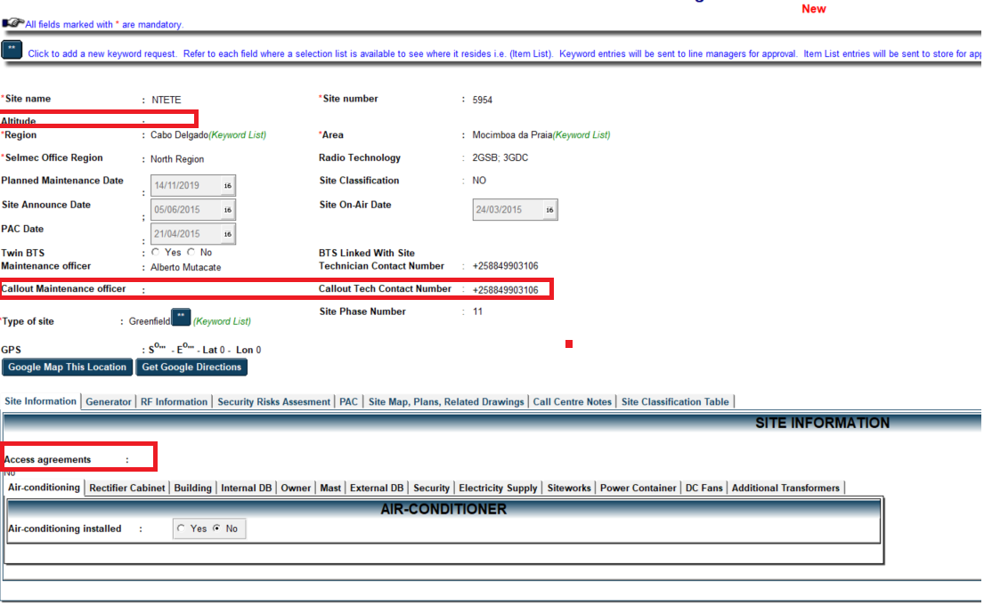

**Site Name** (Editable All Propercase)

**Site Number** (Editable All Propercase)

**Region** (Mozambique Regions)

**Area** (Mozambique Area)

**Comserv Region** (Maputo Region, South Region, North Region, Central Region)

**Radio Technology** (Editable)

**Planned Maintenance Date** (Updated when plan is supplied)

**Site On-Air Date** (Editable)

**PAC Date (Remove)**

**Twin BTS** (Yes/No)

**BTS linked with site** (Select the linked site)

**Maintenance Officer** (Selected from List of Employees, technicians only)

**Maintenance Officer Contact Number** (Updated automatically)

**Type of site** (Select from specified list) Greenfield, Rooftop, BSC, Micro, BSC, All in one, Repeater, Rooftop

**Site Phase Number**

**Coordinates**

**On the rest of the tabs it needs know if the equipment is installed Y/N** (Further detail of the equipment can be added as we require, it will have the same multiple add structure)

**Client Information Tab Details**

**Generator**

**Generator** Type (Cummins, Deutz, Mitsubishi, Perkins, Volvo, Yanmar, Other)

**Output** **KW**

**Model No**

**Engine Serial Number**

**Engine Capacity** (2 Cylinder, 4 Cylinder, 4 Cylinder Turbo, 6 Cylinder)

**Starter Type** (Bosch, Bosch 2 hole, Bosch 3 hole, Cummins, Denso, Perkins)

**Fuel Consumption**

**Airconditioner**

**Manufacturer** (Dunham Bush, Gree, LG, Samsung, etc…)

**Aircon Type** (Air Curtain, Cassette, Clip On, Split Unit, Under Ceiling, Window Wall)

**Model**

**Aircon Number**

**Serial Number**

**BTU**

**Cage Installed** (Yes / No)

**Sleeve Installed** (Yes / No)

**Unit Controller Type** (Sam, V-Con)

**Controller Model**

**Rectifier Cabinet**

**Cabinet Model No**

**Cabinet Number**

**Type** (Battery Tech, Cordex, Delta, Delta Green, Delta Outdoor)

**Input Type (Single Phase, 3 Phase)**

**No of Batteries**

**Battery A/h Capacity**

**Guard Information**

**Guard Name**

**B.I Number**

**NIB**

**Value**

**Job Card**

The job card allows us to report the work done on all sites. We will use these to create comprehensive reporting structures. Click select client to start the process in the case of planned maintenance the files should already have the necessary details.

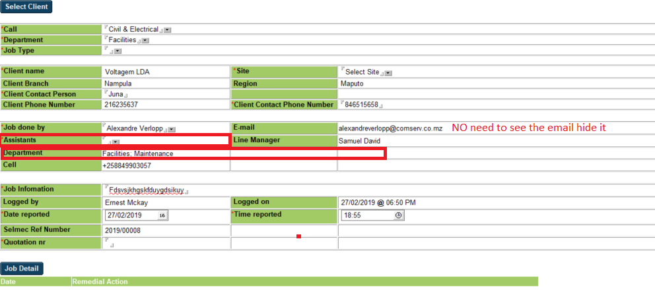

* **Call** (Aircon, Civil & Electrical, Diesel Refuel, Radio & Transmission, Project)
* **Department** (Facilities, Power, Telco)
* **Job Type** (Callout |Corrective, Planned Maintenance | Maintenance Contract)
* **Client Name** select from the list of clients
* **Site** select from sites created or belonging to the client
* **Branch**
* **Contact Person** editable
* **Phone Number** editable
* **Job Done By** select tech
* **Email** automatic based on tech (hide this)
* **Assistants ???**
* **Cell Number** automatic based on tech
* **Job Information** editable
* **Logged By** automatic current user
* **Date Logged** automaticcurrent dat and time
* **Date Reported** date client reported
* **Time Reported** time client reported
* **Comserv Ref Number** auto generated CCM/MMYY0001 (Comserv Client Maintenance for planned and CCO Comserv Call Out)
* **Quotation Number** If needed

**Job Detail**

The job detail is part of the job card. In the case that we work on the same project over a certain period, all job details could be linked to a single job card.

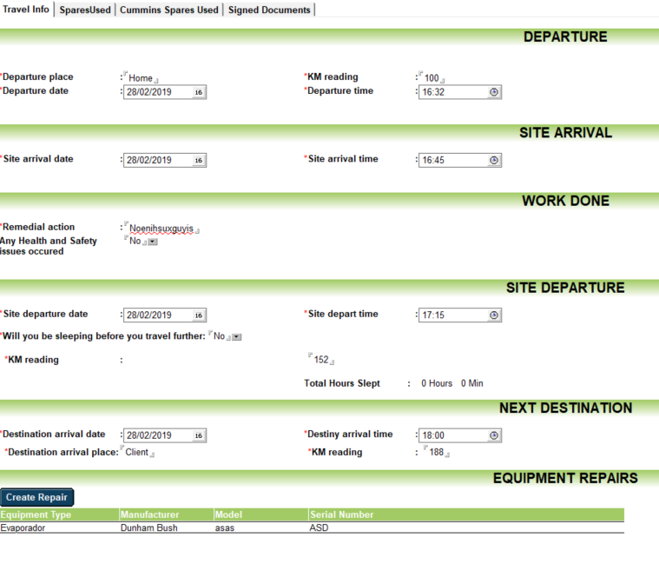

**Travel Info**

* **Departure Place**
* **Departure KM Reading**
* **Departure Date**
* **Departure Time**
* **Site Arrival Date**
* **Site Arrival Time**
* **Site Departure Date**
* **Site Departure Time**
* **Departure KM Reading**
* **NextDestinationArrivalDate**
* **NextDestinationArrivalTime**
* **NextDestinationArrivalPlace**
* **NextDestinationArrivalKMReading**

**Create Repair**

Remedial action or repair records are where technicians can create specific detail as to what they were doing on site or at the client

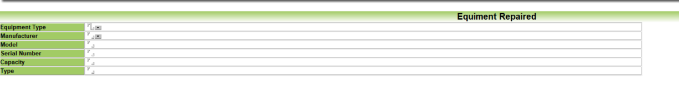

* **Equipment Type**
* **Manufacturer**
* **Model**
* **Serial Number**
* **Job Details**

**Spares Used**

The spares used can only use items that are available by the technician responsible for doing a job. He must only see the spares that he has available in his name. This section is also part of the job detail. The spares used on a job should display in a table on the job.

